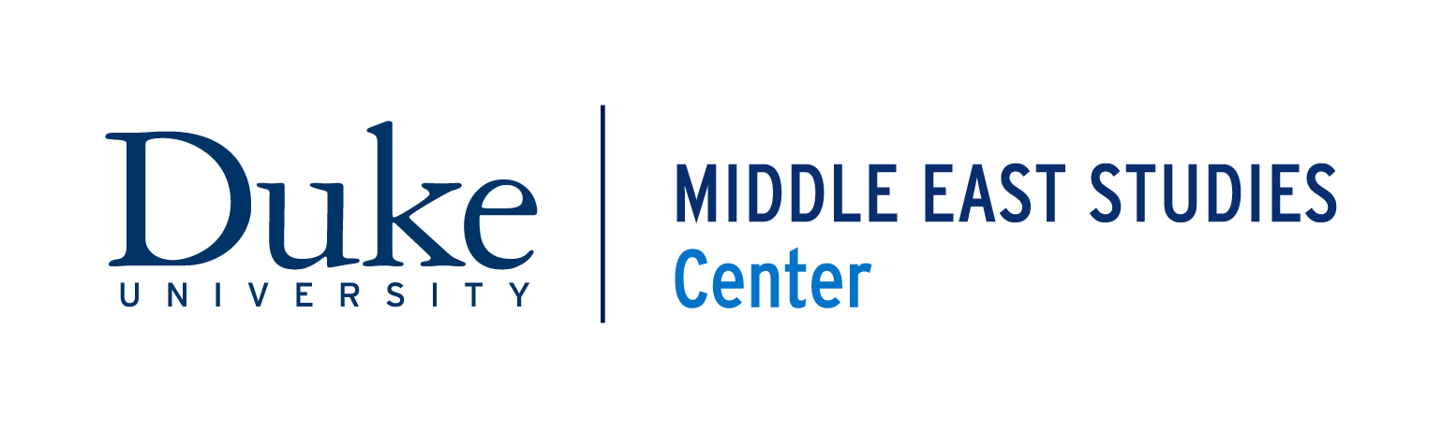
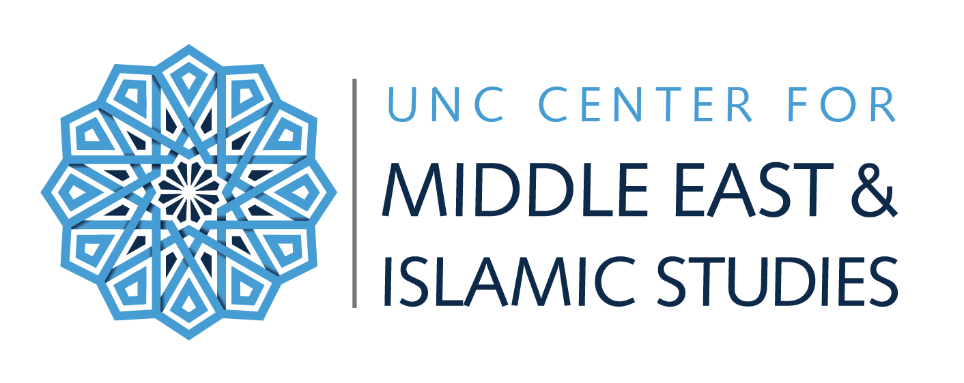
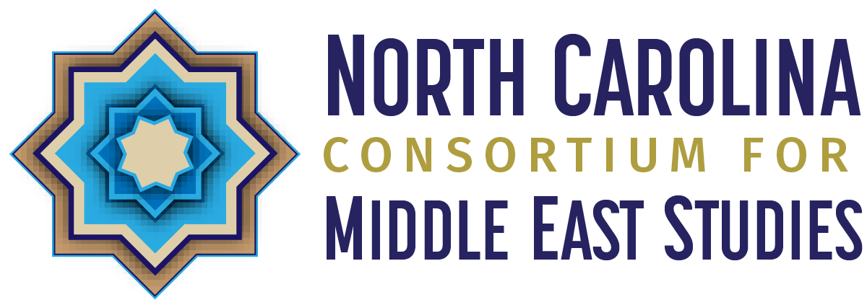

North Carolina Consortium for Middle East Studies Funding Application Form

Please complete this form in full, and submit to mideast@unc.edu for review.

Applicant’s Name: |  |  | Date:
University: |  | Department or Organization:
Email address: | Preferred Mailing Address:

Please provide a brief description of the proposed activity. (250 word maximum)

Proposed date and time of the event:

Amount of funding you are requesting from the North Carolina Consortium for Middle East Studies for this event:
Are you approaching other universities, departments, or units for support? If yes, please list each unit, indicate whether it is the lead sponsor of the event, the amount of funding you are requesting, the commitments they have already made.

Please provide an itemized budget that lists expected expenses. **Please note that funds cannot be used toward food, beverages, or international travel. Funds may be used toward honorarium, domestic travel costs, lodging, publicity, etc.

Please provide any other notes or comments not covered in the above:

Please note: All events sponsored or co-sponsored by the North Carolina Consortium for Middle East Studies require post-event information about attendance. You will be asked to provide this information within a month of your event. If possible, please count people by their affiliation (including: student, staff, faculty, K-12 teacher, member of the public).
☐ Yes, I agree to provide attendance information.

