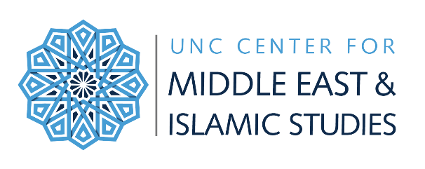
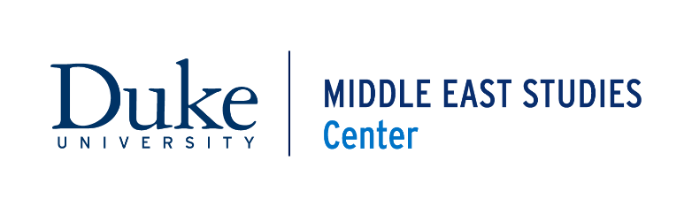
Duke-UNC Consortium for Middle East Studies Outreach Program

Travel Grant Application Form to attend:
Southeast Regional Middle East & Islamic Studies Society
*Please complete this form in full and submit to harver@email.unc.edu.

The Duke-UNC Consortium for Middle East Studies welcomes applications from teachers across North Carolina seeking support to attend the annual fall meeting of the Southeast Regional Middle East and Islamic Studies Society (SERMEISS). SERMEISS is a professional society for educators from various fields whose common connection is the study or teaching of some aspect of the Middle East or Muslim World. Fall meetings are held at the Valle Crucis Conference Center in Banner Elk, NC, and alternate between the second and third weekend of October. Programs are designed to provide for interdisciplinary presentations, feedback, and networking among professors, graduate students, and teachers interested in the Middle East and Islam. For more information, visit https://sites.google.com/su.edu/sermeiss/home.

Guidelines
- This grant is open to all secondary education teachers and community college instructors in North Carolina
- The deadline for applications is September 20 of the desired year
- The applicant must intend on teaching in the consecutive school year
- All awards are a fixed $200, intended as a stipend for travel costs and registration, etc.
- Grant funds are awarded as reimbursements to teachers
- Optional: You may submit your resume or CV along with the completed application

For more information about SERMEISS or the grant application, please contact:
Emma Harver, Program/Outreach Coordinator
Duke-UNC Consortium for Middle East Studies
919-962-6732
harver@email.unc.edu

APPLICANT INFORMATION
Applicant’s Name: |  | Date:
Email Address: | Phone: Is this your: ☐Work ☐Home ☐ Cell
School District or other Educational Affiliation (please, no acronyms):
School/Community College: |  |  | Title I? ☐ Yes ☐ No ☐N/A
School Address: | City: |  |  |  | Zip Code:
Subjects/Courses Currently Taught: |  |  |  | Grade Levels Taught:

TRAVEL GRANT APPLICATION QUESTIONS
1) Do you currently teach about the Middle East in your classroom and if so, which topics do you teach?

2) Please provide a brief description of why you are interested in attending the fall meeting of SERMEISS. How does the Middle East and Islamic Studies-related content align with your intellectual interests? (150 word maximum)

3) How will participation in this professional development opportunity impact your teaching, help improve student learning, and enhance your curriculum? (300 word maximum):

4) Would you still be able to attend the fall SERMEISS meeting without additional financial support?
☐ Yes ☐ No

5) Have you attended a SERMEISS meeting before?* ☐ Yes ☐ No
*Preference will be given to those teachers who have not yet had the opportunity to attend a SERMEISS meeting.

