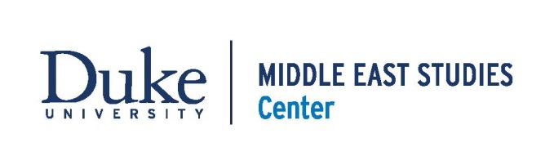
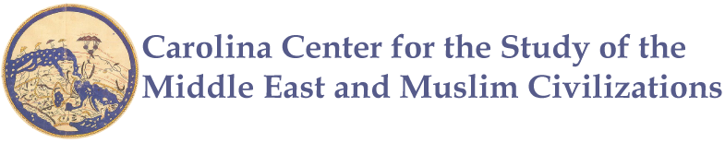
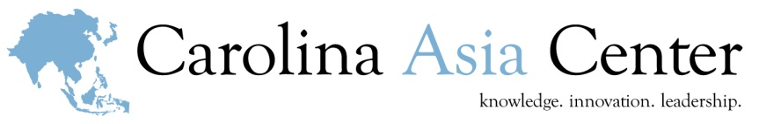
Silk Road, Past and Present: A Workshop for Educators
Saturday, April 8, 2017
Hill Hall, room 103 | UNC-Chapel Hill

SATURDAY, APRIL 8
8:45 Registration & Light Breakfast

9:00-9:15 Welcome & Introductions
Thupten Norbu | Interim Director, Carolina Asia Center
Emma Harver | Outreach Coordinator, Duke-UNC Consortium for Middle East Studies
9:15-10:45 Panel Discussion: History of the Silk Road: Linking East and West
James Anderson | Associate Professor of History and History Department Head, University of North Carolina at Greensboro
Sucheta Mazumdar | Associate Professor of History, Duke University
Communication routes and paths of trade linked the East and West, along which silk and many other goods were exchanged between people from across the world. These vast networks carried more than merchandise, the constant movement and mixing of populations also brought about the transmission of knowledge, ideas, cultures and beliefs. UNCG and Duke University professors of history will discuss these trading routes and their many impacts on society.
10:45-11:00 Break and Walk to the Ackland

11:00-12:20 Art from the Silk Road, Ackland Art Museum
Jenny Marvel | Head of School and Community Programs, Ackland Art Museum
Arts, crafts and technologies were shared and disseminated into societies along the lengths of trade routes, and in this way, languages, religions and cultures developed and influenced each other. In this trip to the Ackland Art Museum we will look at art objects from countries along the Silk Road and discuss the sharing of cultures. The Head of School and Community Programs will also share tips for using works of art in the classroom.
12:20-1:00 Return to the FedEx Global Education Center and Lunch

1:00-2:15 Silk Road Legacies: Contemporary Trade
Giovanni Zanalda | Director of the Duke University Center for International Studies, Associate Research Professor in the Social Science Research Institute, Duke University
International trade continues to be a driving force of the global economy. In this session, we will learn about contemporary trading patterns between East and West.
2:15-3:00 Curriculum Connections
Emma Harver | Outreach Coordinator, Duke-UNC Consortium for Middle East Studies
Sarah Brown | Outreach Program Assistant, Carolina Asia Center
Learn about resources offered by the Carolina Asia Center and Duke-UNC Consortium for Middle East Studies.
3:00-5:15 Film Screening: The Music of Strangers: Yo-Yo Ma and the Silk Road Ensemble
http://www.silkroadproject.org/s/arts-strangers
Discussion with Michael Figueroa | Assistant Professor of Ethnomusicology, UNC Chapel Hill
Over the past 16 years, an extraordinary group of musicians has come together to celebrate the universal power of music. Named for the ancient trade route linking Asia, Africa and Europe, The Silk Road Ensemble, an international collective created by acclaimed cellist Yo-Yo Ma, exemplifies music’s ability to blur geographical boundaries, blend disparate cultures and inspire hope for both artists and audiences. The Grammy-nominated documentary The Music of Strangers: Yo-Yo Ma and the Silk Road Ensemble, follows members of the Ensemble as they gather in locations across the world, exploring the ways art can both preserve traditions and shape cultural evolution. After the film, we will have a discussion with Professor of Ethnomusicology, Michael Figueroa.
5:15-5:30 Wrap Up & Evaluation

This program is generously funded by the Carolina Asia Center and the Duke-UNC Consortium for Middle East Studies.

