Turkey: From the Ottoman Empire to Contemporary History and Politics
A Workshop for Educators
Saturday, December 2, 2017
Ahmadieh Family Conference Hall, RM 240, John Hope Franklin Center
Duke University
WORKSHOP SCHEDULE

8:30-9:00am Registration and Light Breakfast

9:00-9:20am Welcome & Introductions
Emma Harver | Outreach Coordinator, Duke-UNC Consortium for Middle East Studies

9:20-10:30am An Overview of the Ottoman Empire
Sarah Shields | Professor, UNC Chapel Hill Department of History

10:30-10:40am Break

10:40-12:00pm The Ottomans and their Architecture: Exploring the Aya Sofia, Suleymaniye, and Sultanahmet Mosques
Omid Safi | Director, Duke Islamic Studies Center

12:00-1:00pm Turkish Lunch and Ottoman Food Presentation
Hatice Orun Ozturk | Associate Professor, Biomedical Engineering & Electrical and Computer Engineering, NC State University; Creator of turkisheats.com

1:00-1:20pm Break and walk to Duke Library

1:20-2:00pm Yasak/Banned: Political Cartoons from Late Ottoman and Republican Turkey
Thomas DeGeorges | Senior Program Coordinator, Duke Islamic Studies Center
Middle East & Islam in Global Contexts Duke FOCUS Cluster Students

2:00-3:10pm Ottoman Legacies and Turkey Today
Erdag Goknar | Associate Professor in the Department of Asian and Middle Eastern Studies; Director, Duke University Middle East Studies Center

3:10-3:30pm Break and return to the John Hope Franklin Center

3:30-4:30pm Turkish poetry and Spirituality
Omid Safi | Director, Duke Islamic Studies Center

4:30-5:00pm Reflection & Evaluations

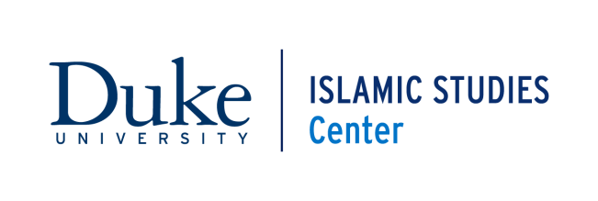
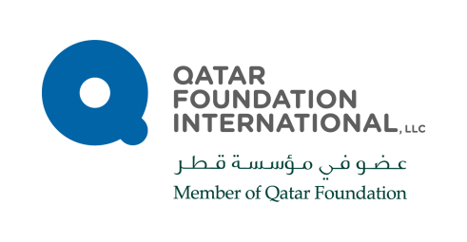
This workshop is presented by the Duke Islamic Studies Center with support from Qatar Foundation International and the Duke-UNC Consortium for Middle East Studies.

